Mid-Year Meeting Tour to JCB and Tour and Lunch at Mighty Eighth Air Force Museum
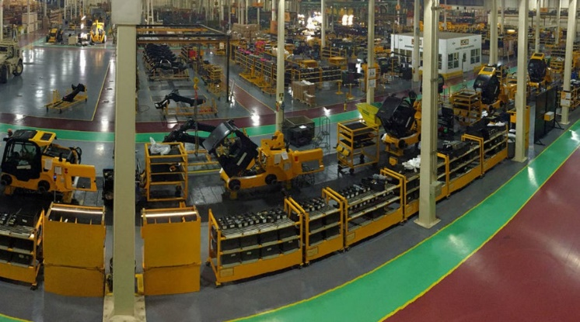
JCB Manufacturing Plant
JCB’s North American Headquarters in Savannah, GA sits on over 1,000 pristine acres facing one of the nations’ busiest highways, I-95. From the 500,000 square foot state of the art facility, JCB headquarters supports a network of over 115 dealers in the United States and Canada, providing parts, training and expertise.
Under the same roof, the Savannah manufacturing floor is proud to be the worldwide production facility for all 18 models of the JCB’s exclusive side-door entry skid steer and compact track loaders and we are always excited to provide customers with a firsthand view of the facility.
Tours are no open to the general public so we are indeed fortunate that they have welcomed NHA members. The visit will begin with a short film introducing the company followed by a factory tour. We will then visit the demo yard for equipment closeups. The total visit will be about 3 hours and there will be about 45 minutes of walking.
Dress for this visit requires long pants, close toe shoes and sleeved shirts.
Mighty Eighth Air Force Museum
The National Museum of the Mighty Eighth Air Force educates visitors through the use of exhibits, artifacts, archival materials, and stories, most of which are dedicated to the history of the Eighth Air Force of the United States Army Air Corps that served in the European Theatre during World War II.
Among the many World War II exhibits are aircraft including a B-17 Flying Fortress bomber that can be viewed while being restored, a model of a Messerschmitt Bf 109G fighter, and a 3/4-scale model of a P-51 Mustang fighter. Aircraft on display outside include the B-47 Stratojet, MiG-17, and F-4 Phantom II from the post-WWII Cold War era.

We will enjoy lunch at the restaurant on site and tour the museum with guides.

We will hop aboard a chartered bus at 8 AM at The Sanctuary for the 2-hour trip to JCB. At approximately 1 PM, we will leave JCB and make the very quick trip to the museum. Lunch will be served immediately and the tour will follow that. We will leave the museum by 4 PM for the return trip and arrive back at The Sanctuary about 6 PM.
Cost of the trip, including lunch, is $60 per guest.

