Golf at Kiawah
Kiawah Golf Resort is known by all avid golfers in the US. The Ocean Course may be the crown jewel at Kiawah Island Golf Resort, but the luxurious resort’s four additional courses collectively form the crown itself.

Designed by some of the sport’s most revered architects—names that include Jack Nicklaus, Tom Fazio, and Gary Player—these courses (as well as the Ocean Course) all benefited from recent renovations that included reseeding with Paspalum on every tee box, fairway, and green. Moreover, the distinct layouts of these four lesser-acknowledged courses, as well as the respective environments in which they are set, allow each course to deliver a unique experience. “That’s what makes Kiawah such a special place for golf,” says Josh Wagaman, the head professional at the resort’s original golf course, Cougar Point. “The five courses are all very different. You won’t get the same experience at any of them.”

Reservations for all courses, except The Ocean Course, can be made individually by visiting https://kiawahresort.com/golf/ and clicking on Reserve a Tee time or call Kiawah Island Golf Resort at 1-800-654-2924. NHA Rate for all courses, other than the Ocean Course, is $150/player.

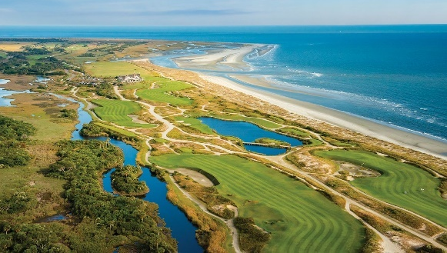
The Ocean Course
The Ocean Course is the most famous course at Kiawah Island, and was designed by Pete and Alice Dye. The course was designed so that players have a view of the shoreline of the Atlantic Ocean, but also to expose golfers to the often-strong winds in the area. The Ocean Course has been consistently named as one of the best courses in the world by several publications such as Golf Digest and Golf Magazine as well as being named a "Certified Audubon Cooperative Sanctuary" by Audubon International. As of 2010, the Ocean Course was rated 25th in Golf Digest's 100 Greatest Golf Courses in America.
The Ocean Course is a par 72 course and from the championship tees, it stretches to 7,876 yards (7,202 m) with a slope rating of 155 and a course rating of 79.1, the highest in the country, according to the United States Golf Association. Because of its large slopes, numerous bunkers, and challenging Bermuda grass, it was named the toughest course in America in 2010 by Golf Digest.
Reservations for The Ocean Course book months in advance. The NHA has reserved three tee times-each for 4 players-during our meeting dates. You must call Sue to reserve a tee time and they will be awarded on a first come-first serve- basis. Tee times are Wednesday, February 23 at 1:10 PM or Thursday, February 24 8:20 AM and 9:40 AM (you would not be able to go on the tour if you select the Thursday times). NHA rate for the Ocean Course is $350/player.
General Policy for The Ocean Course
*The Ocean Course is a walking only facility. All golfers are required to walk. There are no additional fees for caddies with the exception of a recommended gratuity of $100 per player for a walking caddie and $50 per player for a forecaddie. Forecaddies are mandatory for anyone utilizing a golf cart during the summer and carts are always restricted to the path.
* Proper attire is required at all times and is at the discretion of the Golf Staff. Denim of any kind, shorts more than 5" above the knee, bathing suits, athletic style shorts, and shirts without sleeves or collars are considered unacceptable.
* To ensure optimum playing conditions, our club is a non-metal spike facility.

