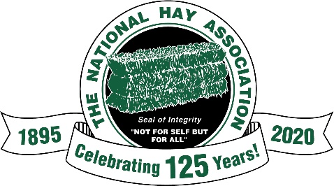
Sponsor Form for the NHA 2020 Zoom Virtual Annual Meeting
All sponsors will receive the following benefits:
- Recognition during the Virtual Annual Meeting
- Ad in the Special Edition Convention Hay There published in October
- Recognition on the NHA Website
- To all our Associate Members- Sponsor at the $100 level and receive all of the above benefits PLUS free exhibit space at the 2021 San Diego Convention!
Sponsor Levels
- Platinum Level - $1,000
- Gold Level - $500-$1000
- Silver Level - $250-$500
- Bronze Level – $100
___________________________________________________________________________
Company Name __________________________________________________________________________________
Individual Name _____________________________________ Email Address_________________________________
Sponsor Level – Indicate the level of sponsorship and mail payment or complete the credit card authorization
__________Platinum Level - $1,000 or more
__________Gold Level - $500 - $1,000
__________Silver Level - $250 - $500
__________Bronze Level – $100
Pay by credit card or checks should be made payable to NHA and mailed to NHA. 4375 Massillon Rd. Unit 769.
Green, OH 44232.

____________________________________________ __________________________________________________
Name on Credit Card Credit Card Number
___________________________ _______________________________ _______________________________
Expiration Date CVC Code Billing Zip Code

