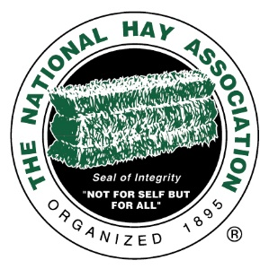
Don Kieffer Memorial Scholarship Application
Don Kieffer was the Executive Secretary of the NHA from 1989 – 2014. This scholarship is awarded in his honor.
$2,000 will be awarded to an NHA member’s child or grandchild who elects to pursue a career in an ag-related field at a US institution:
Applications must be submitted by July 15. Award will be announced by September 1.
In order to qualify, students must meet the following criteria:
- Must be entering second or higher undergraduate year at an accredited junior college, college or university in the United States.
- Must be majoring in an agricultural-related field.
- Must be a child or grandchild of an NHA member.
NHA Company Name ________________________________ NHA Member’s Name_____________________________
Your name ________________________________________ Email ___________________________________________
Address ___________________________________________________________________________________________ Street Address City State Zip
Phone _________________________ Mobile (if different) _________________________ Date of Birth_______________

SCHOOL INFORMATION:
High School Name: City/State: _________________________________High School Cumulative GPA: ________________
Date of High School Graduation: ______________________________________
Please list the post-secondary US institution you are attending: ___________________
What year of college are you currently in? ________________ Anticipated annual cost of attendance: ______________
What is your College Cumulative GPA? ________________ What field do you plan to study? _______________________
What is your college major? _____________________________________________________________
Number of credits completed towards degree: ______________________________
Anticipated date of graduation: __________________________________
Do you plan to attend the same college next year? _______ If not, where will you attend? ______________
Any comments concerning above answers: _____________________________________________________________
_________________________________________________________________________________________________
_________________________________________________________________________________________________
Don Kieffer Memorial Scholarship (pg. 2)
OTHER SCHOLARSHIPS AND GRANTS
Have you been awarded any other scholarships or grants for the upcoming school year? If so, please list below:
Name of Scholarship Grant $ Amount
________________________________________________________ __________________________________
________________________________________________________ __________________________________
________________________________________________________ _________________________________
IN ADDITION TO THE COVER PAGE, APPLICATION REQUIREMENTS INCLUDE THE FOLLOWING:
- Two letters of recommendation with contact information
- Current resume
- Are you registered to vote? ___Yes ___No
- Have you ever voted? ___Yes ___ No
- What does our NHA motto (Not for Self, but for All) mean to you? You may attach a separate sheet

- What are your plans after graduation? You may attach a separate sheet

Note: The completed application will become property of the National Hay Association and essays, etc. may be shared in publications.
Send your completed application to the NHA Office. 4735 Massillon Rd Unit 769. Green, OH 44232.
Questions: Call Sue Arnold at 615-854-5574 or email at nhaexecoffice@gmail.com

